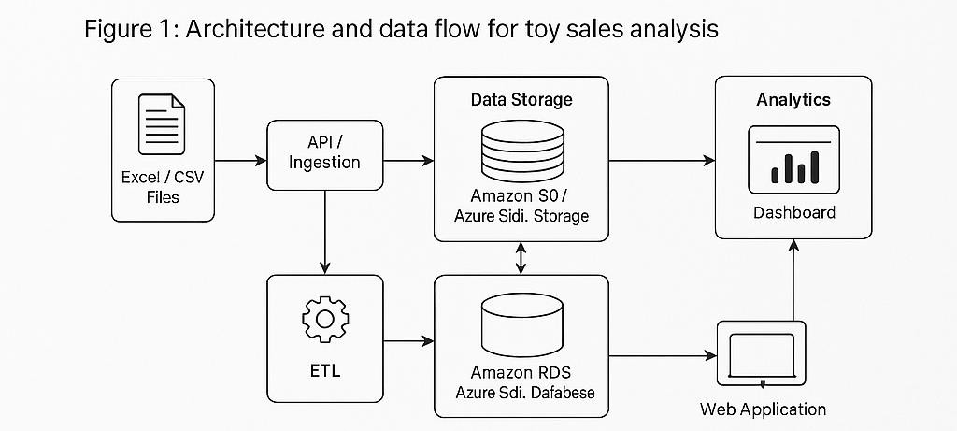

PROJECT DESIGN PHASE

SOLUTION ARCHITECTURE

Date

FEB 2026

Team ID

SBAP0031863

Project Name

T
oyCraft

tales: tableau's vision into
toy manufacturer data

Maximum Marks

4
Marks

S
olution Architectu
re Diagra
m

